Project Development Phase
Model Performance Test

Date | 10 February 2025
Team ID | PNT2022TMIDxxxxxx
Project Name | Script-Controlled ACL – Restrict Record Access Based on Field Value
Maximum Marks

Model Performance Testing:
Project team shall fill the following information in model performance testing template.
S.No. | Parameter | Values | Screenshot
 | Model Summary | Rule-based (non-ML) access-control model: script-controlled ACLs on u_institution_details evaluate the user’s role (bb1–bb4), the data condition (Branch is EEE) and the ACL script (admin / bb1) to allow or deny access. | 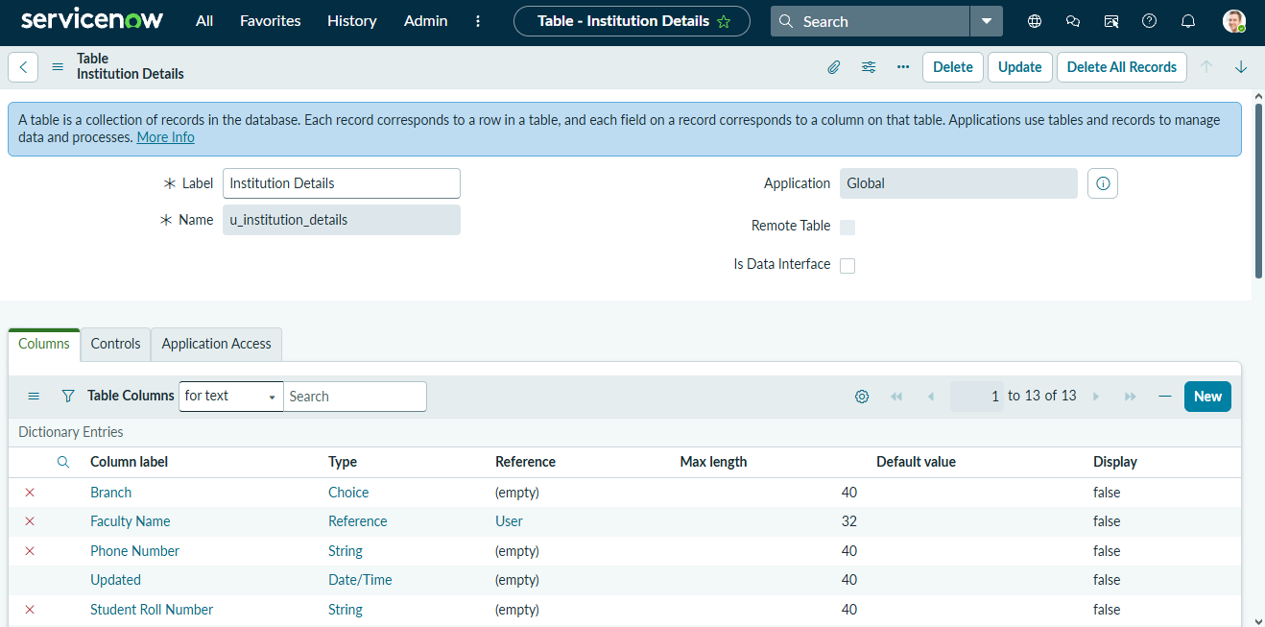
 | Accuracy | Training Accuracy - Not applicable (no trained model)  Validation Accuracy - Access decisions validated by impersonation: bb1 user → only EEE records; Admin → all records; user without role → no records | 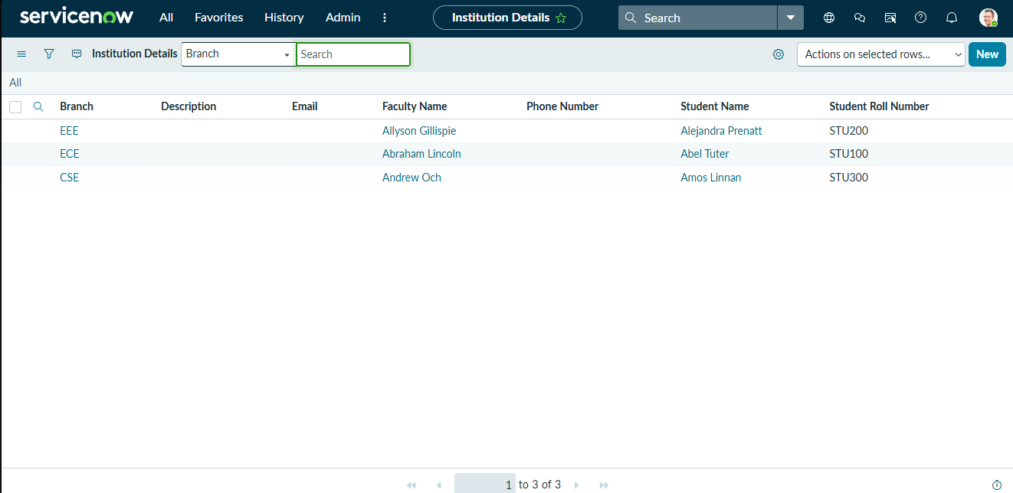
3. | Fine Tunning Result( if Done) | Validation Accuracy - Not applicable (no fine-tuning). The Read ACL was refined with role bb1, data condition “Branch is EEE” and an ACL script. | 